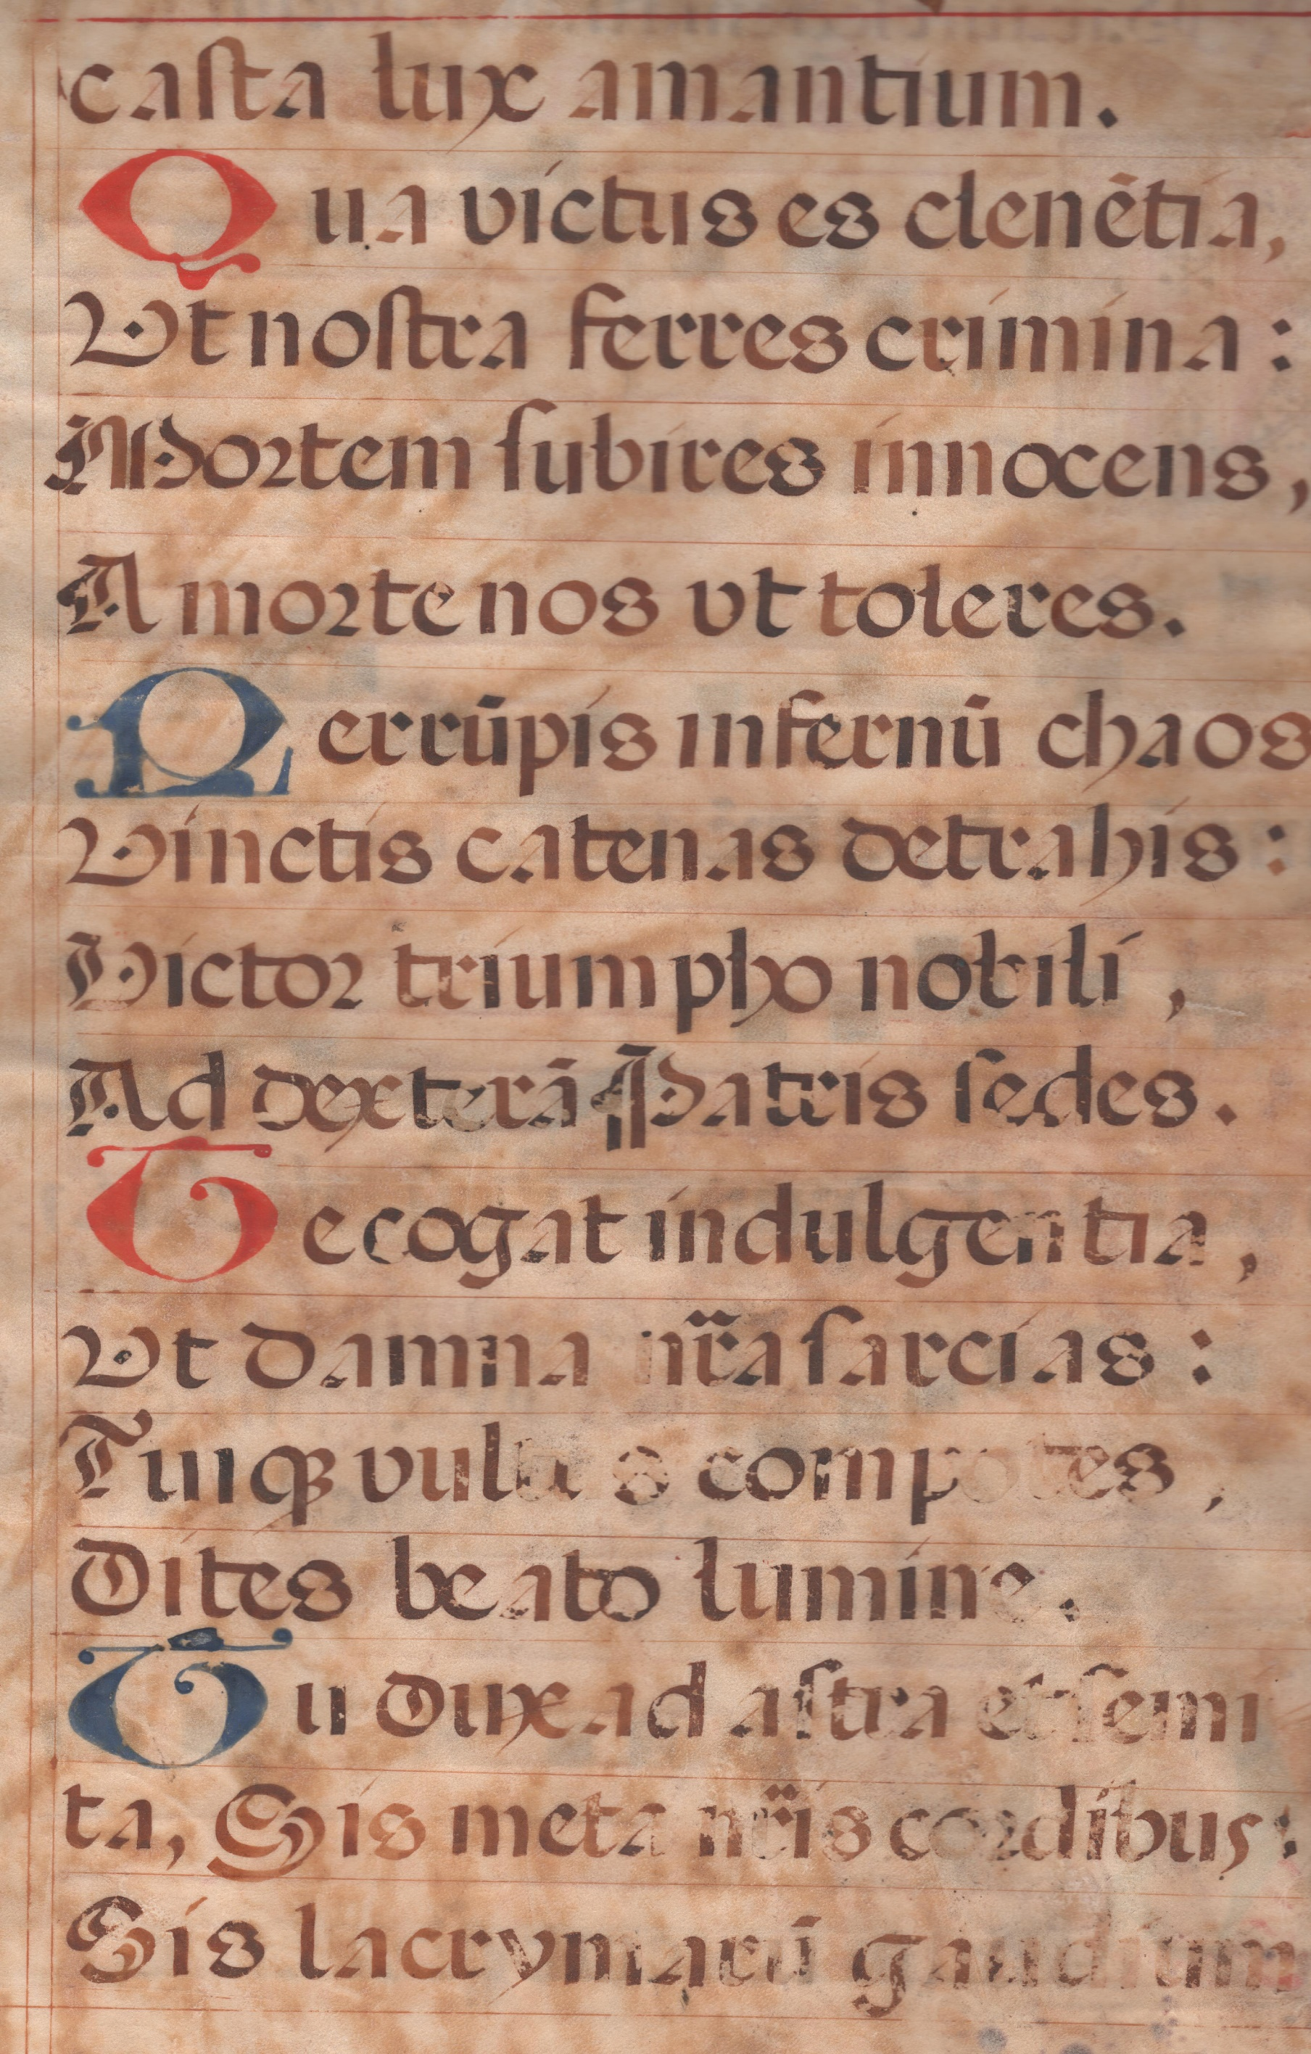

**THE ROTUNDA LETTERFORMS OF**

**A 16th CENTURY ANTIPHONAL FOLIO.**

CSSA May 28th 2023

It is always special and a privilege to study the origins of the letter forms we use today.

Looking at and studying an actual folio page from Spain, written in the 16th Century, is the basis for today’s workshop.

**ROTUNDA** is a hybrid script – Gothic and Round Hand.

**MATERIALS**

Your usual calligraphic basic equipment

2 x A4 sheet tracing paper

Good paper for practicing letters and words

Protractor

Blue or red gouache/ small brush/palette/mixing brush

Walnut or Black ink

**PENS**

Parallel pen 3.8 OR similar size in dip pens

Two other sizes – larger and smaller.

I will be supplying a strip of vellum and a list of words for you to select one. Write it and paint a versal.

SEE YOU ON SUNDAY FOR A USEFUL SCRIPT JOURNEY.